Assessment of nutrient load on the Pregolya River basin (Vistula Lagoon catchment) from the anthropogenic sources

Julia Gorbunova, Atlantic Branch of P.P. Shirshov's Institute of Oceanology of the Russian Academy of Sciences, julia_gorbunova@mail.ru
Boris Chubarenko, Atlantic Branch of P.P. Shirshov's Institute of Oceanology of the Russian Academy of Sciences, chuboris@mail.ru
Dmitry Domnin, Atlantic Branch of P.P. Shirshov's Institute of Oceanology of the Russian Academy of Sciences, dimanisha@rambler.ru
Jens Christian Refsgaard, Geological Survey of Denmark and Greenland (GEUS), jcr@geus.dk

Abstract. The catchment area of the Pregolya River is about 65% of the Vistula Lagoon drainage basin and occupied by Russia and Poland in approximately equal proportions. Nutrient load from the catchment largely controls the eutrophication processes of the lagoon ecosystem. Open statistical data (2011-2014) were used for evaluating the nutrient loads. At present, the nutrient load from the major anthropogenic sources (population, livestock, poultry and crop production) is 41,890 tons N/year and 13,870 tons P/year in the Pregolya River catchment. This results in loads of 11,650 tons N/year and 260 tons P/year when the removal of nutrients by the harvest is taken into account. It was found that the load from anthropogenic sources in the Polish part of the catchment higher than in the Russian part by a factor of three times for nitrogen and similar for phosphorus. The reason for this is that Polish territory is relatively more agriculturally developed leading to a larger nitrogen load. In the Kaliningrad Oblast agriculture declined in the 1990-2000's and now about 50% of arable lands are not used, which creates a potential for development. Currently there is a positive trend of the agriculture development and the "Strategy of socio-economic development of the Kaliningrad Oblast until 2020" is expected to increase arable land by 70%, the number of cattle and pigs by factors of 3.5 and 9.5, respectively. This creates a potential for significant increases of the nutrients loading and eutrophication of the Vistula Lagoon. The nutrient load rise from the anthropogenic sources can be compensated greatly by using the manure as organic fertilizer replacing mineral fertiliser. Even for the worst case scenario three-quarters of the available arable land will be sufficient for utilization of all of the organic fertilizer at the maximum fertilization rate recommended by HELCOM. At the same time more than 80% of the wastewater in Kaliningrad Oblast is not sufficiently treated. This poses a great potential for nutrient load reduction. The calculations showed that equipment of Kaliningrad city with the modern treatment facilities will reduce the nutrient load by 1,400 tons N/year and 290 tons P/year.

Key words: nutrient load, phosphorus, nitrogen, Pregolya River catchment area, Vistula Lagoon

I. Introduction
The Pregolya (Fig. 1) is the largest river that flows into the Vistula Lagoon of the Baltic Sea. Its basin is 65% of the Lagoon’s catchment area and its runoff is 44% of the total [1]. Nutrient load with the Pregolya River flow determines the eutrophication level of the Vistula Lagoon ecosystem largely. At present, there are several expert assessments of nutrients removal with the Pregolya River runoff. It is estimated at about 3,700-4,250 tons N/year and 490-740 tons P/year [2] [3] [4]. Removal of nutrients from the catchment area is determined by the load on the basin area from various sources and their retention in the catchment and hydrographical network.
The aim of the study is to assess the nutrient load (nitrogen and phosphorus) in the Pregolya River Catchment from the major anthropogenic sources: population, livestock and poultry, crop production. It also takes into account the removing of nutrients by the harvest. The study does not include an assessment of nutrients input from the natural landscapes, atmospheric deposition and retention in the catchment and river network.
The actual nutrient load from the anthropogenic sources was assessed from 2014 data. In addition, the potential changes were analysed for two scenarios of human activity evolution (the preservation of trends and planned development).
The transboundary catchment position of the Pregolya River causes difficulties for the assessment. The Pregolya River flows through the territory of the Kaliningrad Oblast and its main tributaries (the Angrapa and Lava) originate in the Warminsko-Mazurskie and Podlaskie Voivodships of Poland. The catchment area is occupied by Russia and Poland in approximately equal proportions – 49% and 51% respectively. In addition, a small part of the Pregolya River catchment (about 0.5%) is in the territory of Lithuania. The transboundary position of the catchment causes diverse social and economic conditions within the basin, because different countries have developed different management and decision-making systems. To obtain reliable results, a unified methodological approach of evaluating human impact across countries was applied.

II. Materials and methods.
The same methods of calculation of nutrient load for different national parts of the catchment were used in the study.
The anthropogenic sources of nutrient load in the catchment area were identified. The data were obtained from archives and electronic databases of the Territorial Authority of the Federal State Statistics Service in the Kaliningrad Oblast and Statistical Office in Olsztyn (http://kaliningrad.gks.ru, http://olsztyn.stat.gov.pl) as well as from literature.
To calculate the emissions of nutrients from the population a complete list of all localities and their inhabitants number was produced (the data are geographically referenced). The gross emissions [5] of 13.5 g nitrogen/person per day and 2.1 g phosphorus/person per day were used.
In the calculations of nutrients input from livestock, the annual load of nitrogen and phosphorus were determined according to the daily manure production per animal, content of nutrients in manure, the number of livestock and poultry in the farms and enterprises and households. The following manure daily production per animal were used in the estimations: cattle - 50 kg, pigs – 5 kg, goats and sheep - 3 kg, chickens - 0.16 kg [6]. The approximate chemical composition of manure for nitrogen and phosphorus, respectively, were assumed as follows: cattle - 0.5%, 0.2%; pigs - 0.6%, 0.2%; goats and sheep - 0.8%, 0.2%; chickens - 1.6%, 1.3% [6]. Nitrogen losses during the accumulation were taken as follows: 25% - for cattle, 15% - for pigs, 25% - for goats and sheep, 25% - for poultry. Nitrogen losses during the storage of organic fertilizers were taken as 30% (for all types) [7].

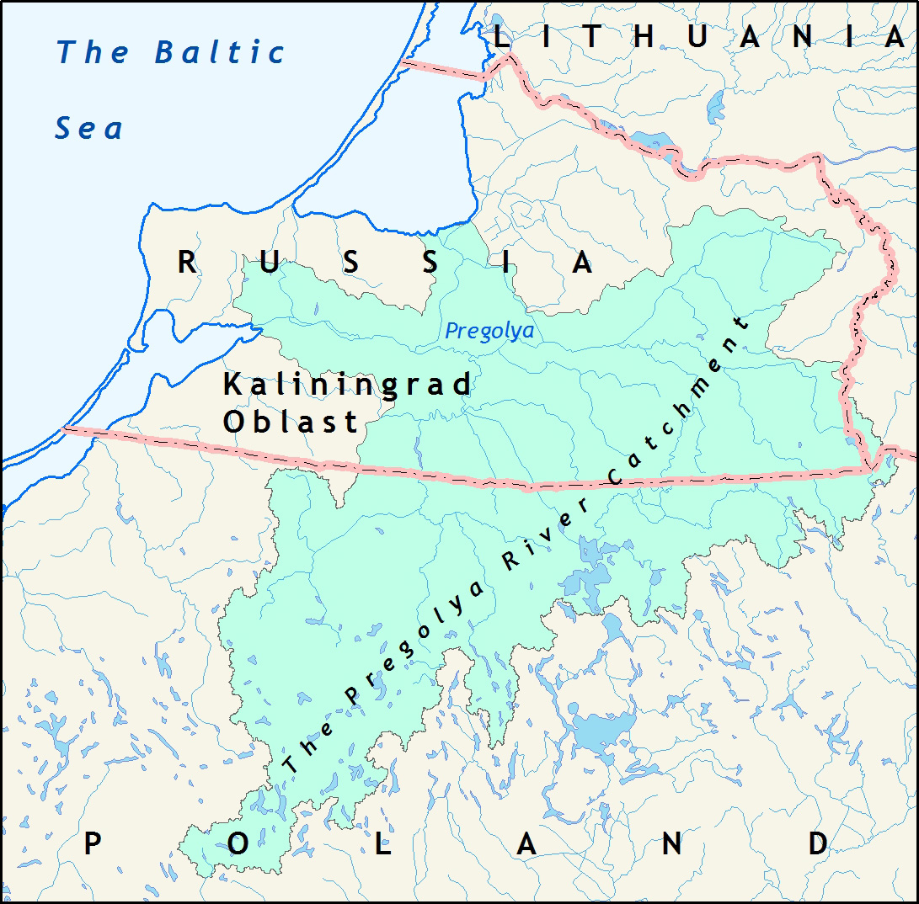
Fig. 1. The study area - transboundary catchment of the Pregolya River

An evaluation of nutrient load from livestock is of great complexity, because the result may vary by several times depending on the waste disposal methods. In this calculation, we estimated that all manure that was produced within the catchment area is used as fertilizers for agricultural lands. A similar approach was used in the assessing the Neva River catchment area [8]. An evaluation of the area actually used for arable land was carried out using the open access data for administrative districts [9]. With the existing map for zoning of the Kaliningrad Oblast [10] according to administrative district occupied by the sub-catchment area, the areas of arable land were calculated for these sub-catchment areas. The agricultural crop yield was estimated by statistical data [9, 11]. The following removal ratios were used for the main cultivated plants: crops – 330 kg/km², potato – 15 kg/ km² [6], rape and oilseeds – 160 kg/km² [12]. Most of the soils in the catchment are sod-podzolic.

III. Results and discussion
The basin is located in an agriculturally developed area, especially the Polish part. The Russian part of the catchment is mainly rural area too. Large industry facilities, such as Kaliningrad pulp and paper mills, have not operated since 2000s. Agriculture, which came into decay in 1990s-2000s, has intensified slightly in recent years. Agricultural development is now one of the priorities of the Kaliningrad Oblast policy.
Thus, population, livestock including poultry breeding and crop production are the main anthropogenic sources of nutrients in the Pregolya River catchment area. Kaliningrad, the largest city of the region, is situated in the mouth of the river. Kaliningrad sewages are discharged directly to the Vistula Lagoon bypassing the Pregolya River. Therefore, the population of the Kaliningrad is not considered for nutrient load in the Pregolya River catchment calculations. Instead, the nutrient load from Kaliningrad was assessed separately as this source is of great importance.

Population
There are 660,000 inhabitants in the Russian part and 330,000 inhabitants in the Polish part of the Pregolya River catchment. Most of the population in the Russian part lives in Kaliningrad city (450,000 people).
In the Russian part of the catchment 90% of urban population and 30% of inhabitants in the rural areas are connected to the sewerage network [13], while the corresponding numbers in the Polish part are 97% and 43%, respectively [14]. Three cities in the Russian part of the catchment have biological treatment systems: Guryevsk (50% of discharges), Krasnoznamensk (80%), Gusev (100%) [13]. In the Polish part nearly all wastewaters (98%) are treated [14]. For all treatment facilities, except Olsztyn, the values for the biological treatment (without chemical and denitrification) are adopted. The degree of removal of nutrients during treatment are: 17% for the total nitrogen, and 25% for the total phosphorus [15]. In the case of Olsztyn the treatment plants include phosphorus removal and a denitrification unit: the degree of removal of total N is 70%, total P is 98%. In the case of households that are not connected to the sewage system, the degree of purification of waste water is 13% for total nitrogen and 10% for total phosphorus, adopted as in the case of a septic tank [16].
The load of total nitrogen and total phosphorus from point sources (the part of population connected to sewerage system) and urban areas (population without the sewerage system) are presented in Table 1.

Livestock and poultry farming
The livestock (cattle, pigs, goats and sheep) and poultry number was estimated from statistical data for administrative districts [17, 18]. A geographically referenced list of livestock and poultry enterprises and farms was compiled for Russian part. Livestock in households was calculated according to the rural population number [19]. The number of cattle in the Polish part is almost 3 times larger than in the Russian part of the catchment (143,000 and 52,000, respectively). The number of pigs in the Polish part is almost 1,3 times larger than in the Russian part (165,000 and 128,000, respectively) [17, 18]. According to data of 2014, the largest number of cattle and pigs in the Russian part were in the agricultural enterprises, while previously (2011), the number of cattle in households was almost equivalent to the number in agricultural enterprises, 45% and 51%, respectively. The number of poultry in the Russian part is almost 2 times more than in the Polish part of the catchment area (1,990,000 and 1,060,000 respectively). Most of the poultry in the Russian part is chicken, while half of the number in the Polish part is turkey.
The loads of total nitrogen and total phosphorus from livestock and poultry in the Pregolya River catchment area are presented in Table 1.

Crop production
It was difficult to evaluate the area of the arable lands in Russian part of the catchment. Available cartographic materials and spatial planning schemes contain the information only on lands nominally attributed as arable. In reality, less than 50% of the available arable land is used in the Kaliningrad Oblast. To assess the area actually used as arable the open access data for administrative districts was used [9]. The area of arable land in the Russian part is about half of the area in the Polish part. The use of mineral fertilizers in agricultural land is on average 65.2 kgN/ha and 14.6 kgP/ha for the Warmińsko-Mazurskie Voivodship [18] and 18 kgN/ha and 2.7 kgP/ha for the Kaliningrad Oblast [20]. The load of nutrients from mineral fertilizers in the Pregolya River catchment is presented in Table 2.
For the nutrient balance the nutrient removal by the harvest is important as well as the load from anthropogenic sources (Table 1).
Chemical fertilizers and livestock waste are the most significant sources of nutrients. Poultry breeding is important for phosphorus emission in the Russian part of the catchment area. (Fig. 2, 3).

Table 1. The main components of anthropogenic nutrient load in the Pregolya River catchment for 2014 (RU – the Russian part; PL – the Polish part).
Component of the anthropogenic load | Total Nitrogen |  | Total phosphorus
Component of the anthropogenic load | RU | PL | RU | PL
Component of the anthropogenic load | tons/year | tons/year | tons/year | tons/year
Point sources (population connected to the sewerage system)*  Total catchment area | 640 | 1,160 | 100 | 110
 | 1,800 |  | 210
Urban areas (population without sewerage system)  Total catchment area | 540 | 500 | 90 | 75
 | 1040 |  | 165
Mineral fertilizers  Total catchment area | 6,000 | 20,000 | 900 | 4,500
Mineral fertilizers  Total catchment area | 26,000 |  | 5400
Organic fertilizers (livestock waste)  Total catchment area | 3,614 | 7,939 | 1,928 | 4,430
Organic fertilizers (livestock waste)  Total catchment area | 11,554 |  | 6,358
Organic fertilizers (poultry waste)  Total catchment area | 976 | 519 | 1,133 | 602
Organic fertilizers (poultry waste)  Total catchment area | 1,495 |  | 1735
Total nutrient load from the main anthropogenic sources  Total catchment area | 11,770 | 30,118 | 4,151 | 9,718
 | 41,888 |  | 13,868
Removal of nutrients by harvest  Total catchment area | 8,920 | 21,315 | 4,020 | 9,585
Removal of nutrients by harvest  Total catchment area | 30,235 |  | 13,605
Total nutrient load from the main anthropogenic sources after considering removal by harvest  Total catchment area | 2,850 | 8,803 | 131 | 133
 | 11, 653 |  | 263
Notes: * - Kaliningrad city is not taken into account

a | b
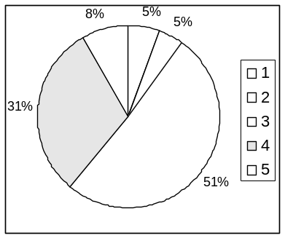 | 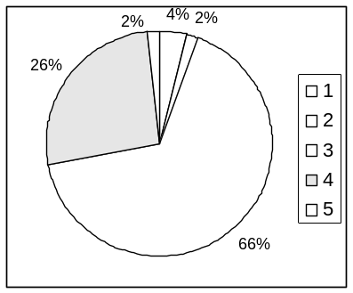
Fig. 2. Proportion of the main anthropogenic sources of total nitrogen in (a) Russian part and (b) Polish part of the Pregolya River catchment area: 1 – point sources (population connected to the sewerage system); 2 - urban areas (population without the sewerage system); 3 - mineral fertilizers; 4 - organic fertilizers (livestock waste); 5 - organic fertilizers (poultry waste).

a | b
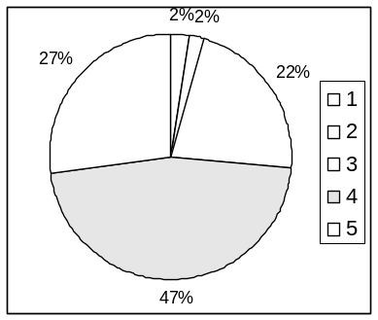 | 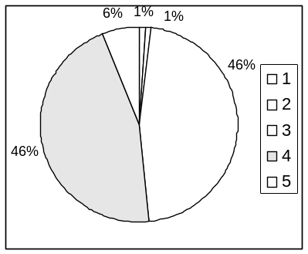
Fig. 3. Proportion of the main anthropogenic sources of total phosphorus in (a) Russian part and (b) Polish part of the Pregolya River catchment area: 1 – point sources (population connected to the sewerage system); 2 - urban areas (population without the sewerage system); 3 - mineral fertilizers; 4 - organic fertilizers (livestock waste); 5 - organic fertilizers (poultry waste).

Potential changes of the nutrient load due to different scenarios of human developments in the Pregolya River catchment
Two scenarios were formulated to assess possible changes of anthropogenic load as a result of alternative assumptions on human activities in the Pregolya River catchment.
Business as usual (BAU) - the scenario assumes preservation of the observed trend of development of agriculture and population. The last five years trends where analyzed for Russian and Polish parts of the Pregolya River catchment for arable lands, livestock of pigs and cattle and population (Table 2).
Documented future, official projections (DF). Further socio-economic development of Warmian-Masurian Voivodeship and environmental measures significantly depends on the implementation of the European Union program "Operational Program Eastern Poland 2014-2020". A significant increase in agricultural production is not expected [21, 22]. Analysis of the "Strategy of socio-economic development of the Kaliningrad Oblast in the long term" showed an expected increase in the area of arable lands by 70%, as well as cattle livestock and pigs by factors of 3.5 and 9.5, respectively (Table 2) [23]. As for population – a significant effect of the “Program of the Kaliningrad Oblast to assist the voluntary resettlement to the Russian Federation of compatriots living abroad” is expected. According the Strategy of Development of Kaliningrad Oblast the population in the Oblast is expected to increase up to 1.6 million people by 2020 [23].

Table 2. Quantitative assessment of agricultural developments for two different scenarios in the Pregolya River catchment.
 | Business As Usual (BAU) |  | Documented Future (DF)
 | Russian part | Polish part | Russian part | Polish part
Arable | +5% | 0% | +70% | +3%
Livestock
Pigs | +15% | 0% | +950% | +5%
Cattle | +15% | 0% | +350% | +5%
Population | +25% | -6% | +70% | +3%

In the case of implementation of BAU scenario (development in accordance with the existing trends), the total load from anthropogenic sources will increase by 997 tons N/year and 356 tons P/year, i.e. by 2.5% (Table 3). In the case of implementation of the plans of Kaliningrad Regional Government in accordance with the “Strategy of Economic Development of the Kaliningrad Oblast until 2020“ (DF scenario) the significant rise of nutrient load by 22,760 tons N/year and 9,909 tons P/year is expected, i.e. the total load from anthropogenic sources will double (removing by the harvest is not considered).

Table 3. Changes of the main components of the anthropogenic nutrient load in the Pregolya River catchment for two different scenarios: Business as usual (BAU) and Documented Future (DF)
Component of the anthropogenic load | BAU |  | DF
Component of the anthropogenic load | N total | P total | N total | P total
Component of the anthropogenic load | tons/  year | tons/  year | tons/  year | tons/  year
Point sources (population connected to the sewerage system) | +90 | +18 | +483 | +73
Urban areas (population without the sewerage system) | +105 | +18 | +393 | +65
Mineral fertilizers | +300 | +45 | +4,800 | +765
Organic fertilizers (livestock waste) | +501 | +275 | +17,086 | +9,006
Organic fertilizers (poultry waste) | 0 | 0 | 0 | 0
Total nutrient load from the main anthropogenic source | +997 | +356 | +22,761 | +9,909
Removing of nutrients by harvest * | +446 | +201 | +6,883 | +3,102
Total nutrient load from all anthropogenic sources with considering removing by the harvest t | +551 | +155 | +15,878 | +6,808
Note: * an increase in the runoff with the harvest is calculated in accordance with the increasing cultivation area, without taking into account changes in productivity.

A part of the increased load of nutrients will be removed by harvest (Table 3). Nutrient removal by harvest is calculated according to the extension of the arable lands and does not take into account the productivity increase, Hence the harvest removal is likely to be underestimated.
Both scenarios show an increase of the anthropogenic nutrient load due to intensification of agriculture, and, above all, livestock in the Russian part of the catchment area. The effect of this can be compensated greatly by utilising the manure as organic fertilizer replacing mineral fertiliser (not shown in Table 2). In this respect, HELCOM recommends an upper limit of manure at 170 kg nitrogen and 25 kg of phosphorus per hectare per year. It is noted that even for the worst case scenario DF, 75% of the available arable land will be sufficient for utilization of all the organic fertilizer at the rate recommended by HELCOM.

Kaliningrad wastewater
The wastewaters of Kaliningrad are mechanically treated only (mechanical filters operate with substantial overload) and it is discharged directly into the Vistula Lagoon through an open canal built as early as 1904 [24]. It is estimated that about 1,390-1,400 tons N/year and 240-400 tons P/year remove from the Kaliningrad sewage canal [2,4]. Based on the 2014 population number we estimated the load of 1990 tons N/year and 310 tons P/year.
The construction of a sewage treatment plant for the city of Kaliningrad began in 1976 but was not completed, and it was re-started in 2009. The operational scheme of the treatment facilities will provide full biological wastewater treatment with nitrogen and phosphate removal and advanced treatment in compliance with the standards of the Helsinki Commission [25]. Currently, the project is not yet complete. The completion date for the project was once again postponed.
Introducing the modern treatment facilities in the Kaliningrad city will reduce the nutrient load by 1400 tone N/year and 290 tone P/year (Table 4). But if the treatment facilities will not be completed, the nutrient load will increase by 220 tons N/year and 80 tons P/year in the case of the BAU scenario; and by 1,390 tons N/year and 500 tons P/year in the DF scenario.

Table 4. Changes in nutrient load from Kaliningrad in cases of the introducing of the waste water treatment plant for the ‘Business as usual’ and ‘Documented development’ scenarios.
Nutrients | Waste water treatment plants | BAU | DF
Total nitrogen | -1,400 | +220 | +1,390
Total phosphorus | -290 | +80 | +500

IV. Conclusions
1. The nutrient load from the major anthropogenic sources (population, livestock, poultry and crop production) is 41,890 tons N/year and 13,870 tons P/year on the Pregolya River catchment area at present. Total nutrient load from the main anthropogenic sources after considering removal by harvest is estimated as 11,650 tons N/year and 260 tons P/year. The nutrient load from the Kaliningrad wastewaters is about 1,990 tons N/year and 310 tons P/year (sewages are discharged directly to the Vistula Lagoon and only mechanically untreated at present).
2. The proportion of the anthropogenic nutrient load for the different national parts of the Pregolya River catchment is such that the nitrogen load is three times larger from the Polish part compared to the Russian part, while the phosphorus loads are similar.
3. Chemical fertilizers and livestock waste are the most significant sources of nutrients. Poultry breeding is important for phosphorus emission in the Russian part of the catchment area. Nutrient load from the population is noticeable only from the city of Kaliningrad.
4. Potential changes of the nutrient load were calculated for two future scenarios (BAU scenario – development in accordance with current trends; DF scenario – the official plans of the local authorities). For the BAU scenario the total anthropogenic load of nutrients will increase slightly – by 2.5%. For the DF scenario, a significant rise of nutrient load is expected. Hence, the load from the anthropogenic sources will double (removing by the harvest is not considered).
5. The nutrient load rise from the anthropogenic sources (in accordance with the scenarios) can be compensated greatly by production of organic fertilizer from all of the livestock and poultry waste and use the organic fertiliser to replace mineral fertiliser. Even for the worst case scenario DF, three-quarters of the available arable land will be sufficient for utilization of all of the organic fertilizer at the maximum rate recommended by HELCOM.
6. The calculations showed that equipment of Kaliningrad city with the modern treatment facilities will reduce the nutrient load by 1,400 tons N/year and 290 tons P/year.

V. Acknowledgement
Data collection was made under support of the theme № 0149-2014-0017 of State Assignment of the P.P.Shirshov Institute of Oceanology of the Russian Academy of Sciences (2015-2017). Preparation of this article was made under the support of the grant RFBR-Bonus 14-05-9173015 "Reducing nutrient loadings from agricultural soils to the Baltic Sea via groundwater and streams (Soils2Sea)".

V. REFERENCES
[1] M.V. Silich, “Balance of the Lagoone”, Hydrometeorological regime of the Vistula Lagoon. Leningrad: Gidrometeoizdat, 1971, pp. 143-172.
[2] S.V. Aleksandrov, J.A. Gorbunova, ”Nutrient load for the Vistula Lagoon from the Pegoliy River flow”, Water: chemistry and ecology, vol. 1, pp. 4-8, 2010.
[3] S.I. Zotov, Modeling of geosystems. Kaliningrad: KSU, 2001.
[4] BASE project 2012-2014, “Assessment and quantification of nutrient load to the Baltic Sea from Kaliningrad Oblast and transboundary rivers, and the evaluation of their sources”. HELCOM, 2014.
[5] “What does domestic wastewater contain?”, Swedish Environmental Protection Agency Report 4425. Stockholm, 1995
[6] The methodology of calculation of the removal of nutrients and evaluation of long-term state of pollution of small rivers, vol. 331. Belarus: Ministry of Natural Resources and Environmental Protection of the Republic of Belarus, September1999.
[7] “Rulebook for environmentally friendly agricultural practices in a Leningrad Region Russia”, Livestock and fodder production, part 1. St. Petersburg, 2006.
[8] A.A.Ershova, “Comprehensive evaluation of nutrient inputs from the catchment area of the Neva River in the eastern Gulf of Finland”. PhD dissertation, St. Petersburg, 2013.
[9] The arable lands and gross harvest of agricultural crops in the Kaliningrad region in 2014: Statistical Yearbook. Kaliningrad: Federal State Statistics Service, 2015.
[10] D.A. Domnin, B.V. Chubarenko, Atlas of river basins of transboundary Kaliningrad Oblast. Kaliningrad: Tera Baltika, 2007.
[11] “Kaliningrad Oblast and Warminsko-Mazurskie Voivodship in numbers 2014”, Statistical Yearbook by Territorial Authority of the Federal State Statistics Service in the Kaliningrad Oblast and Statistical Office in Olsztyn. Olsztyn: Statistical Office in Olsztyn, 2015.
[12] A. Shcherbakov, The spring oil-bearing plants. Minsk: FUAinform, 1999.
[13] “Sewerage in the Kaliningrad Oblast in 2014”, Statistical Yearbook. Kaliningrad: Federal State Statistics Service, 2014.
[14] Statistical Yearbook of Warmińsko-Mazurskie Voivodship 2014. Olsztyn: Statistical Office in Olsztyn, 2015.
[15] “Nutrient Loads to the Swedish Marine Environment in 2006”, Sweden's Report for HELCOM's Fifth Pollution Load Compilation. Stockholm: Naturvardsverket, 2009.
[16] B. Liss, “Quantification of nitrogen and phosphorus load from local on-site wastewaters treatment”. Degree dissertation, Uppsala: Universitet, 2003
[17] Agriculture of the Kaliningrad Oblast: Statistical Digest. Kaliningrad: Federal State Statistics Service, 2014.
[18] Statistical Yearbook of Agriculture 2014. Warszawa: Central Statistical Office, 2015.
[19] Rural settlements: Statistical Digest. Kaliningrad: Federal State Statistics Service, 2014.
[20] “Fertilisation and chemical land reclamation in 2014”, Statistical Yearbook. Kaliningrad: Federal State Statistics Service, 2015 22p.
[21] “Regional Development Strategy of the Voivodeship of Warmia and Mazury until 2020”, Annex to Resolution, vol. XXXIV/ 474/05. Voivodeship of Warmia and Mazury of 31 August 2005.
[22] Population projection for Poland 2008–2035. Warszawa: Central Statistical Office, 2009.
[23] Strategy of socio-economic development of the Kaliningrad Oblast till 2020, vol. 583. Kaliningrad: Governor of the Kaliningrad region, August 2012.
[24] State of the environment and its impact on the health of the population of the Kaliningrad Region in 2007. Kaliningrad: Federal State Statistics Service, 2008.
[25] Baltic Sea Action Plan, Krakow: HELCOM ministerial meeting. November 2007.

